Session 3: In-class exercises and homework

Exercise 1:

Using Atlas, build a starting concept set for malnutrition.

1. Go to Atlas: <https://atlas-demo.ohdsi.org/>
2. In the Search window, look up Nutritional deficiency disorder (SNOMED CT 70241007)

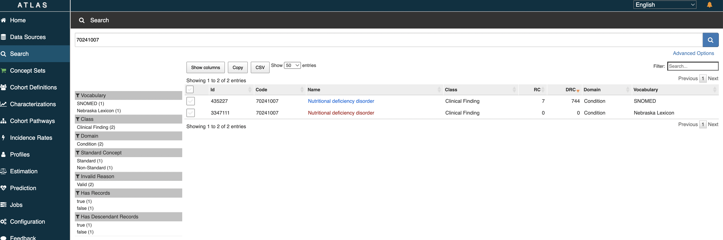

1. Include all descendant concepts and click “Add to Concept Set”

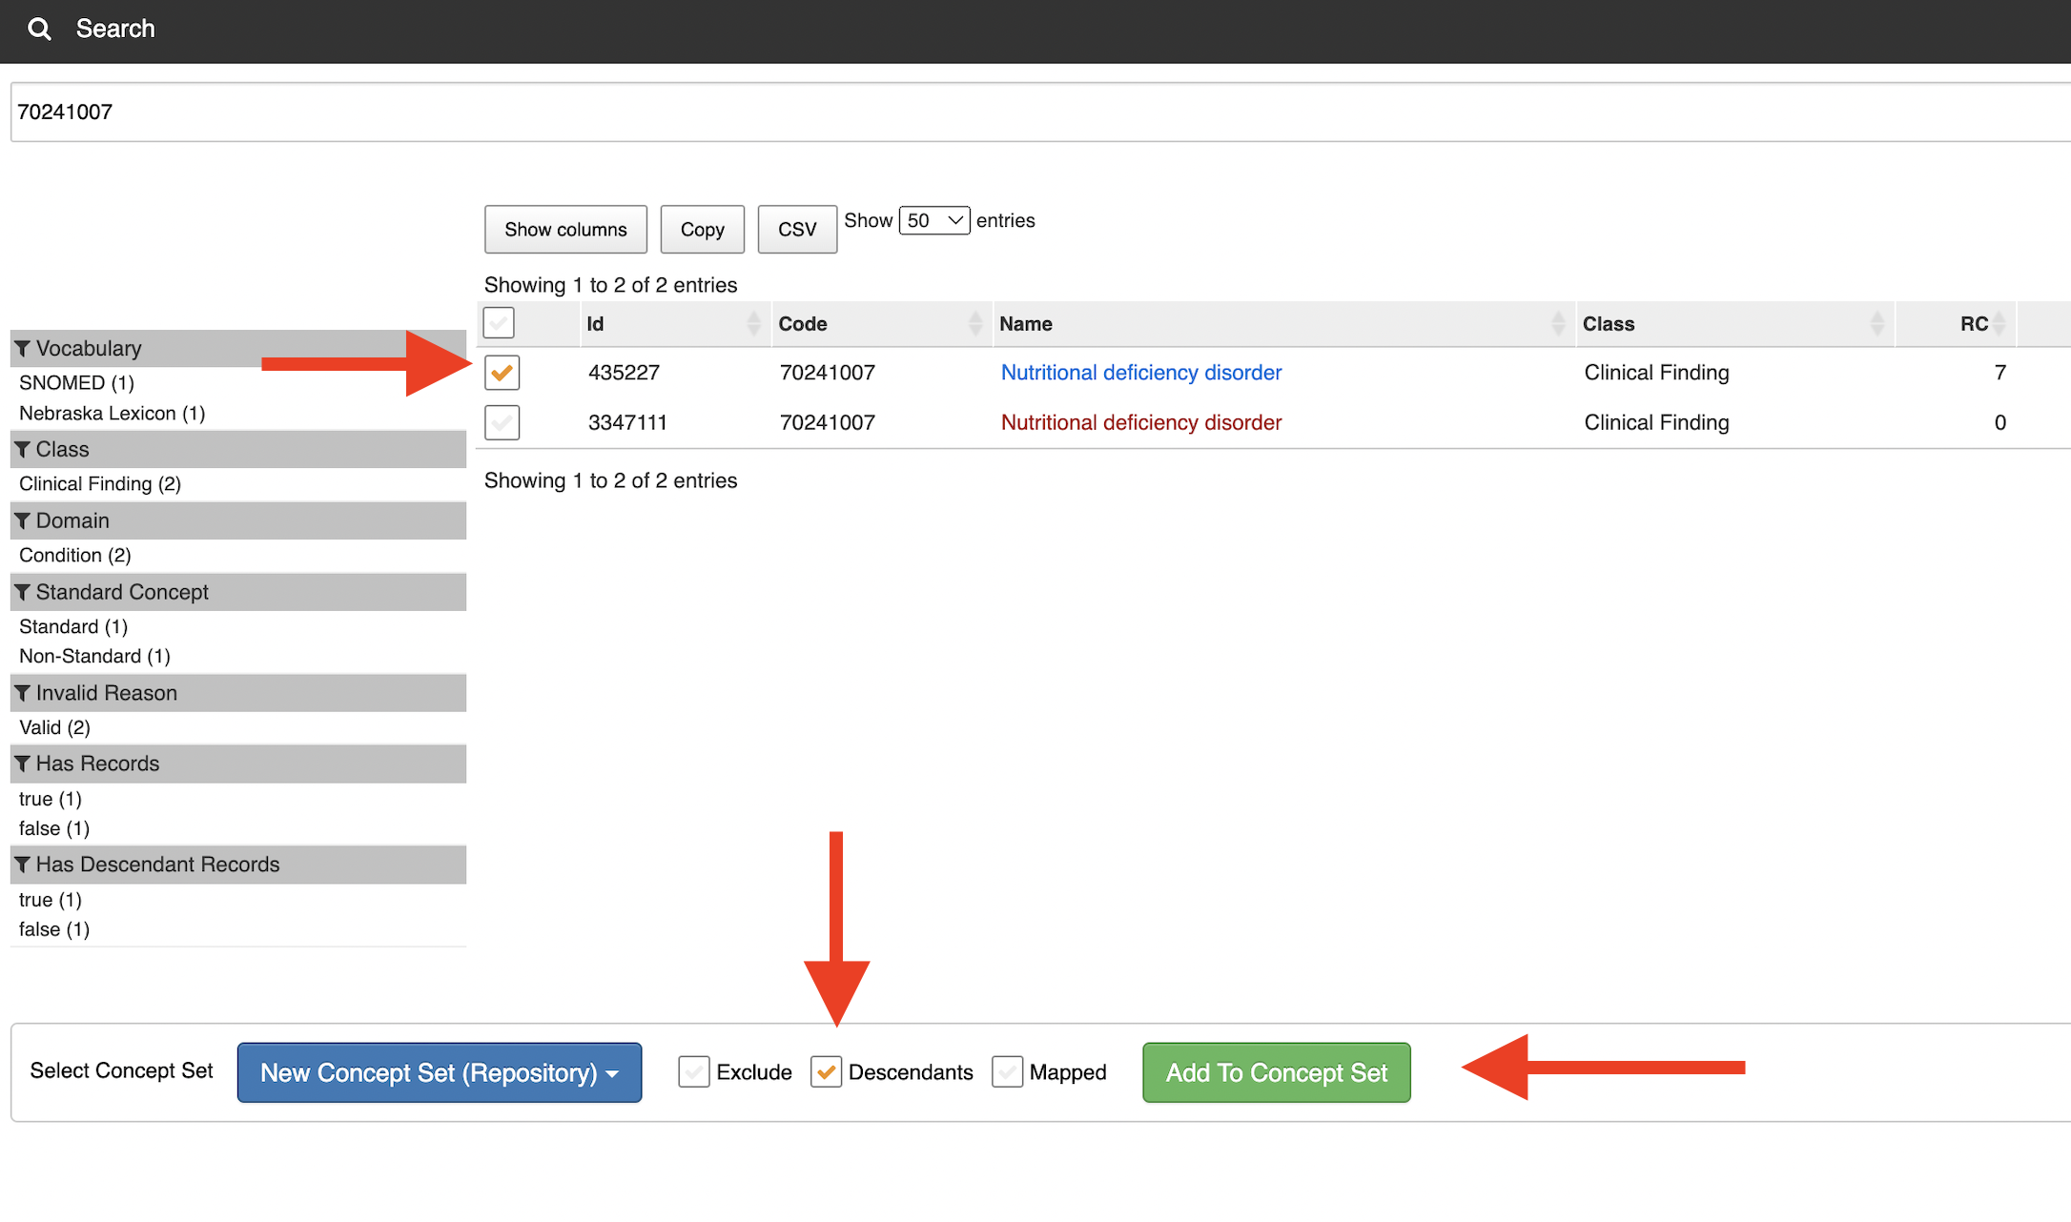

1. View concept set and extract it as a csv using the “Included Concepts” tab

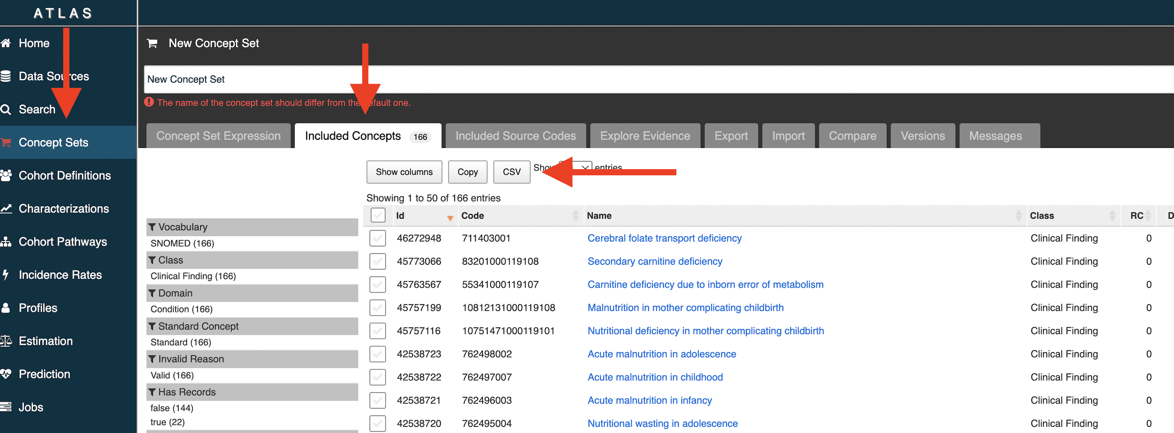

Exercise 2:

Using Atlas, refine previous concept set to include only Deficiency of Macronutrients.

1. Starting with Nutritional deficiency disorder (SNOMED CT 70241007) from the search window, click the concept and navigate to the ”Hierarchy” tab

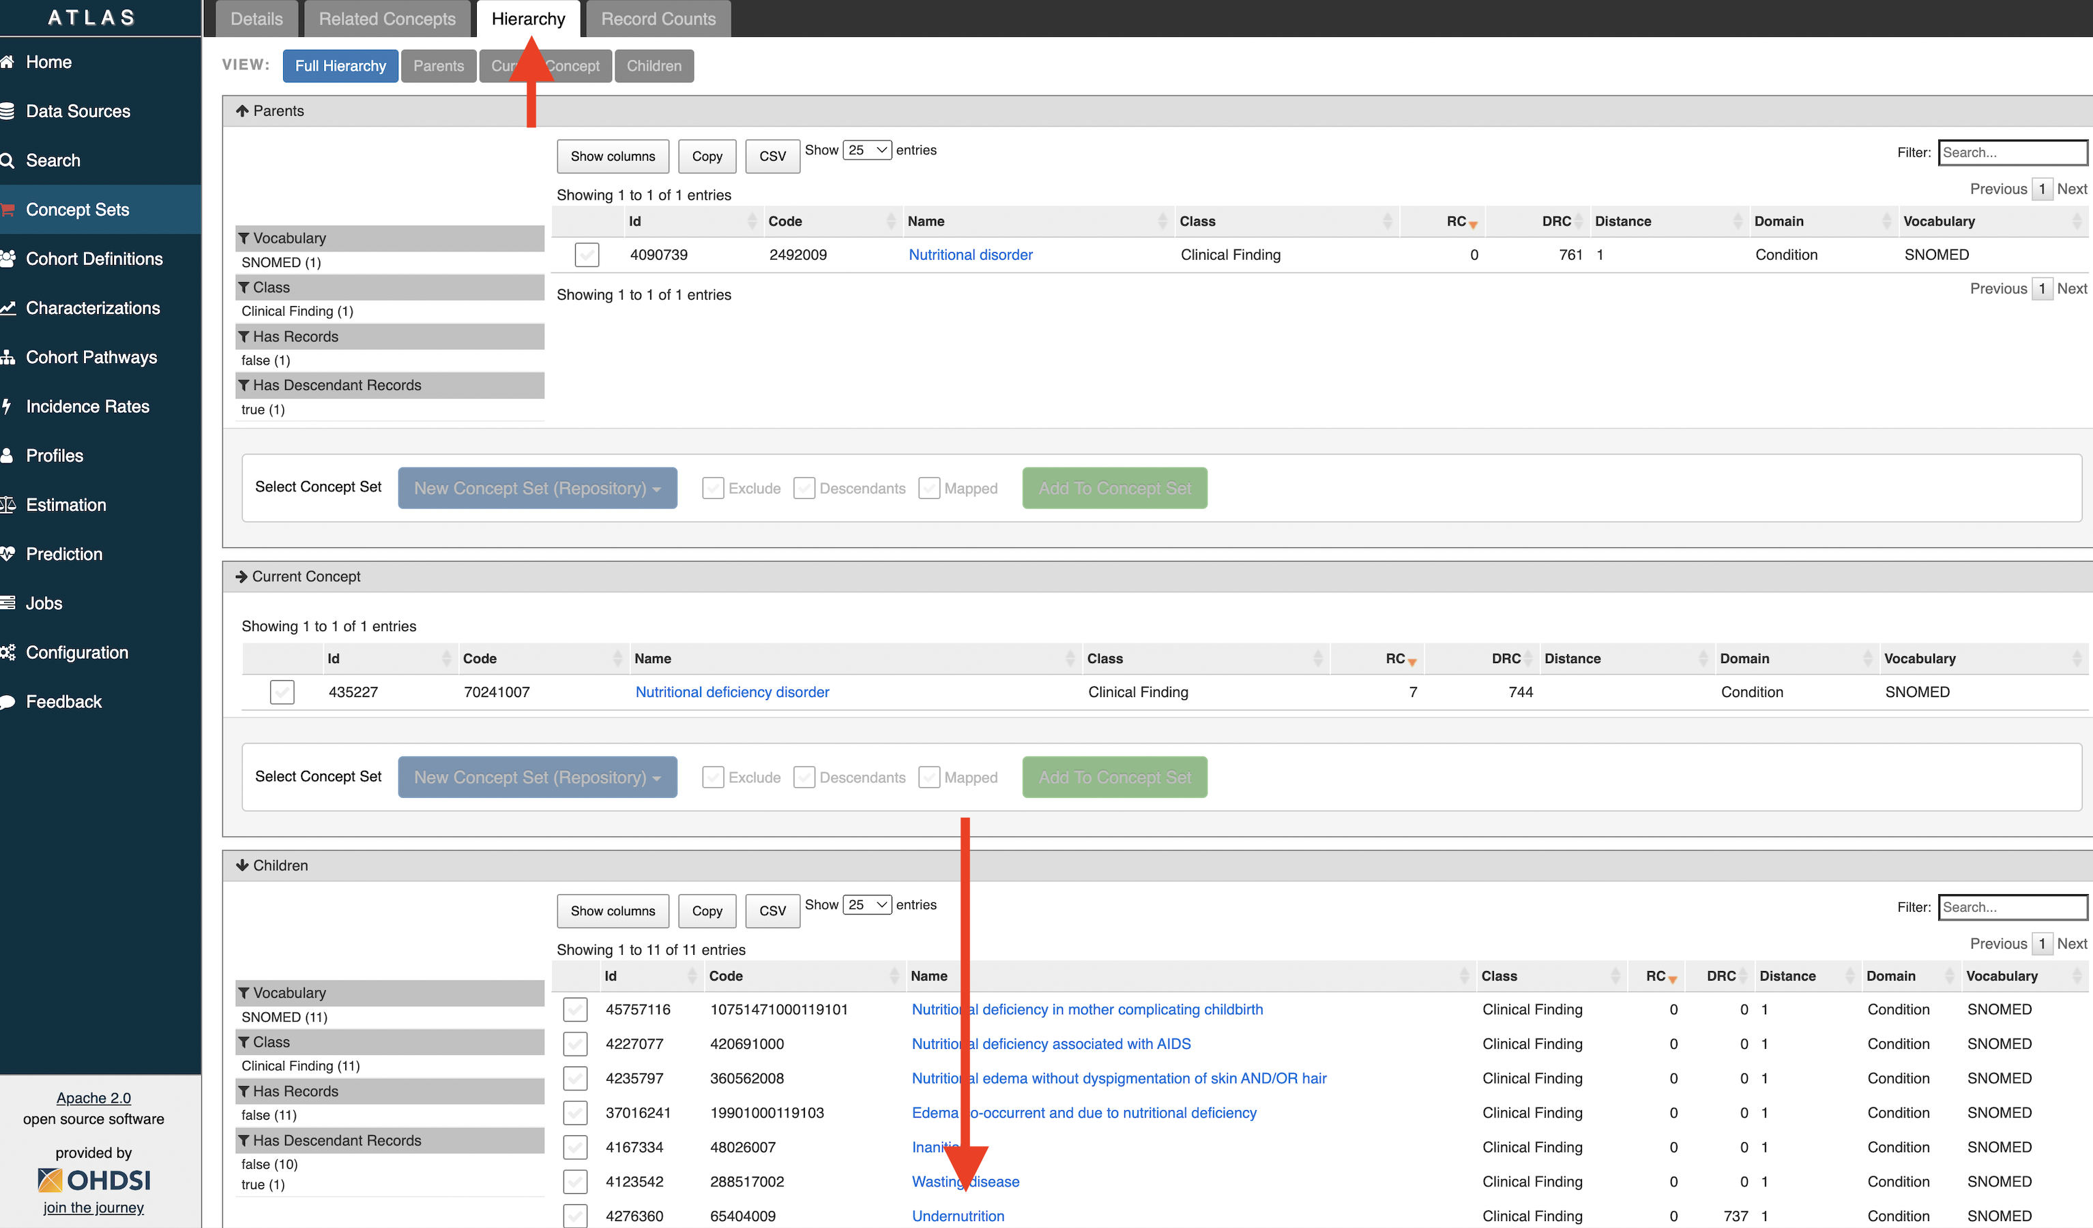

1. Go to the descendant concept “Undernutrition” and navigate to the ”Hierarchy” tab
2. Create a new concept set using Deficiency of macronutrients (SNOMED CT 238107002) and add all descendant concepts

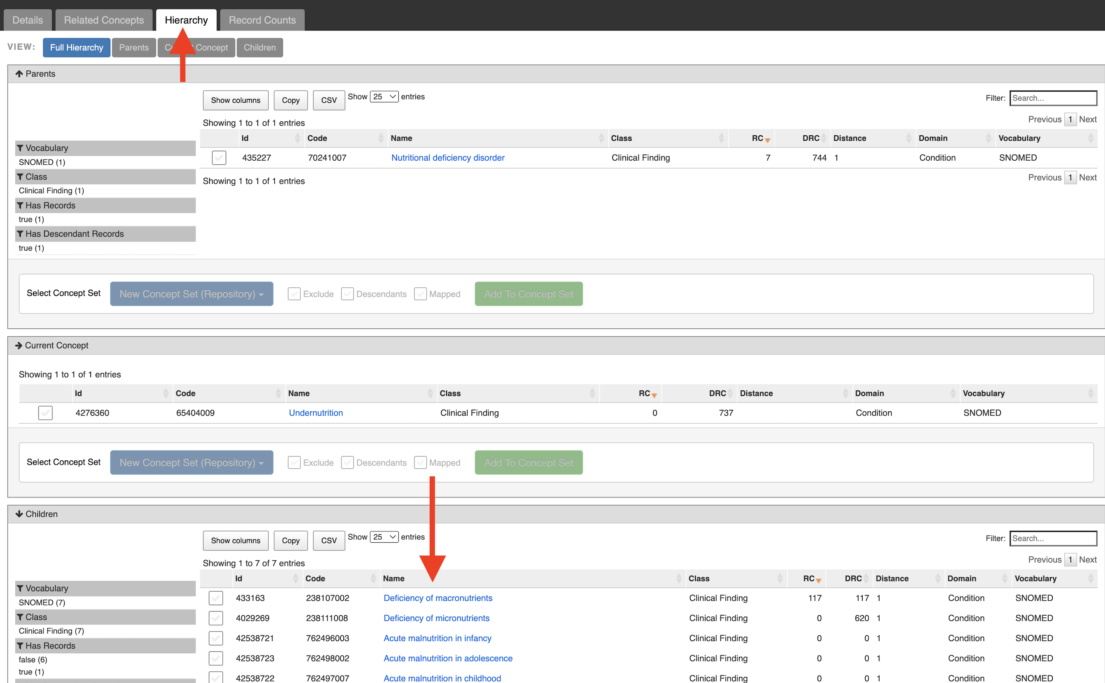

1. Extract concept set as a csv

Exercise 3

Single-Table Query

1. Create a new folder in your workspace and call it Session 3. Within this, create a new code workbook called “Malnutrition Conditions.”
2. Import the concept table from the data catalog:
   1. Click ”Import dataset”
   2. Navigate to the data catalog and find the folder “OMOP Concepts”
   3. Select concept and import into your code workbook
3. Select the concept table and select “new transform” then select “SQL code.” Name the transform exercise_3
4. Write a query to return the concept_id for Nutritional deficiency using the vocabulary_id ”SNOMED.” Save the results to a dataset by toggling “Save as dataset” and run the transform.

SQL code below (in white font, so highlight it):

SELECT concept_id

FROM concept

WHERE vocabulary_id = 'SNOMED'

AND concept_code = '70241007'

Exercise 4:

Single-Table Query

1. Import the concept_ancestor table from the data catalog:
   1. Click ”Import dataset”
   2. Navigate to the data catalog and find the folder “OMOP Concepts”
   3. Select concept_ancestor and import into your code workbook
2. Select the concept_ancestor table and select “new transform” then select “SQL code.” Name the transform exercise_4
3. Write a query to return every descendant_concept_id for Nutritional deficiency using concept_id returned in exercise 3. Save the results to a dataset by toggling “Save as dataset” and run the transform.

SQL code below (in white font, so highlight it):

SELECT descendant_concept_id

FROM concept_ancestor

WHERE ancestor_concept_id = 435227

Exercise 5:

Multiple-Table Query

1. Select the resulting transformation from exercise 4 (should be called exercise_4) and select “new transform” then select “SQL code.” Name the transform exercise_5.
2. On the new exercise_5 transformation, add an additional input for the dataset from for the concept table used in exercise 3.
3. Write a query to return the resulting set from exercise 4 using a JOIN with the concept table and only include those concepts that are standard concepts using the standard_concept column (standard_concept = ‘S’). Save the results to a dataset by toggling “Save as dataset” and run the transform. (Note: don’t be surprised when this is the same result as exercise 4 since we are sticking within one vocabulary)

SQL code below (in white font, so highlight it):

SELECT e.descendant_concept_id

FROM exercise_4 e

INNER JOIN concept c on c.concept_id = e.descendant_concept_id

WHERE standard_concept = 'S'

Exercise 6:

Multiple-Table Query

1. Import the condition_occurrence table from the data catalog:
   1. Click ”Import dataset”
   2. Navigate to the data catalog and find the folder “De-Identified Data”
   3. Select condition_occurrence and import into your code workbook
2. Select the condition_occurrence table and select “new transform” then select “SQL code.” Name the transform exercise_6.
3. Add a second input on the new transformation using the resulting transform from exercise 5 (should be called exercise_5). This can be done by clicking the “+” icon in the SQL transform or going to the “Inputs” tab at the bottom of the transform.
4. Select a data partner to be discussed in class and rite a query to return every row in the condition_occurrence table from that data partner with a matching condition_occurrence_concept_id from the resulting set of exercise 4. You will need to filter on data_partner_id (either in the WHERE clause or in the JOIN). Only include malnutrition records prior to the start of the COVID-19 pandemic in the US (hint: condition_occurrence_start_date prior to ‘2020-01-01’). Save the results to a dataset by Go through the entire process (exercise 1 through 6) with the parent code for rheumatoid arthritis (69896004): <https://snomedbrowser.com/Codes/Details/69896004>. Save the results in a new workbook and name it “Rheumatoid Arthritis.”
5. toggling “Save as dataset” and run the transform.

SQL code below (in white font, so highlight it):

SELECT c.*

FROM condition_occurrence c

INNER JOIN exercise_5 e5 ON e5.descendant_concept_id = c.condition_concept_id AND c.data_partner_id = 198 AND c.condition_start_date < '2020-01-01'

Homework!

1. Follow the steps above, but this time for the micronutrient deficiency SNOMED CT code you identified in exercise 2. SNOMED CT: 70241007. Save the results in a new workbook and name it ”Micronutrient Deficiency.”
2. Go through the entire process (exercise 1 through 6) with the parent code for rheumatoid arthritis (69896004): <https://snomedbrowser.com/Codes/Details/69896004>. Save the results in a new workbook and name it “Rheumatoid Arthritis.”
3. Deploy the Logic Liaison All Patients template
   1. Create a new code workbook and name it Logic Liaison All Patients
   2. Skip the step to import a dataset
   3. Import the template: [LOGIC LIAISON TEMPLATE] L2 and L3 Fact Tables: All Patients
   4. Keep the template as is, but toggle all datasets to save
   5. Run all transforms